JList.
We will now develop a program like this:
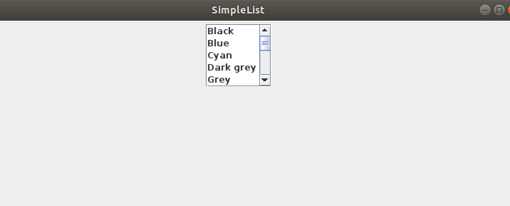

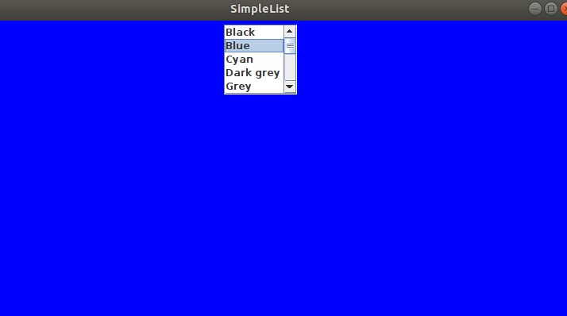

We create a project called list1 and add a java class called frame:
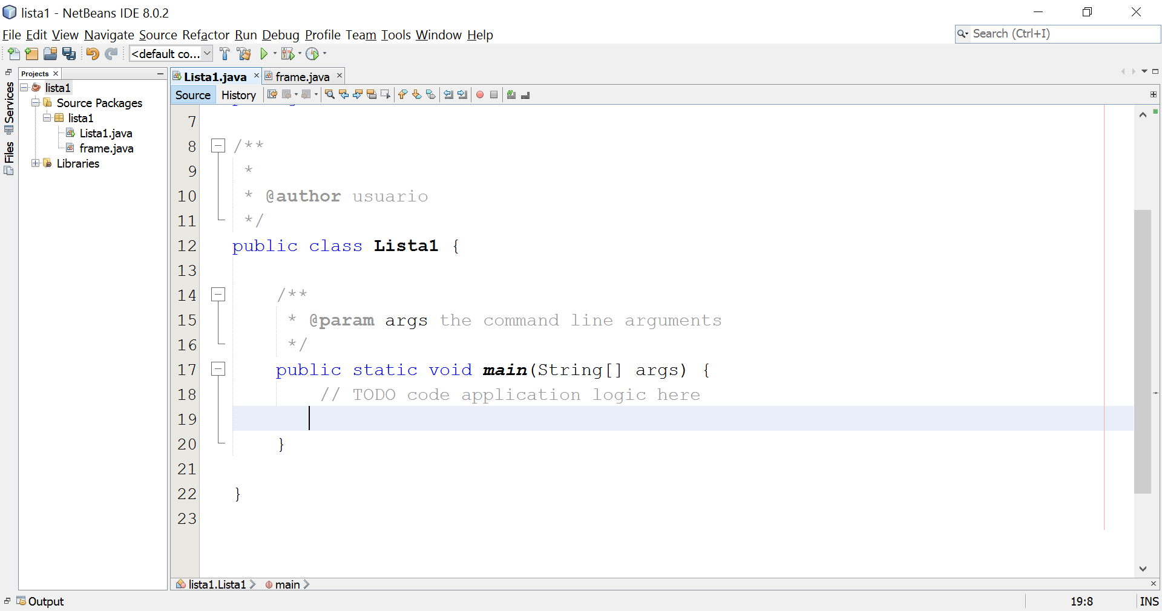
In frame.java I create the minimal window structure:
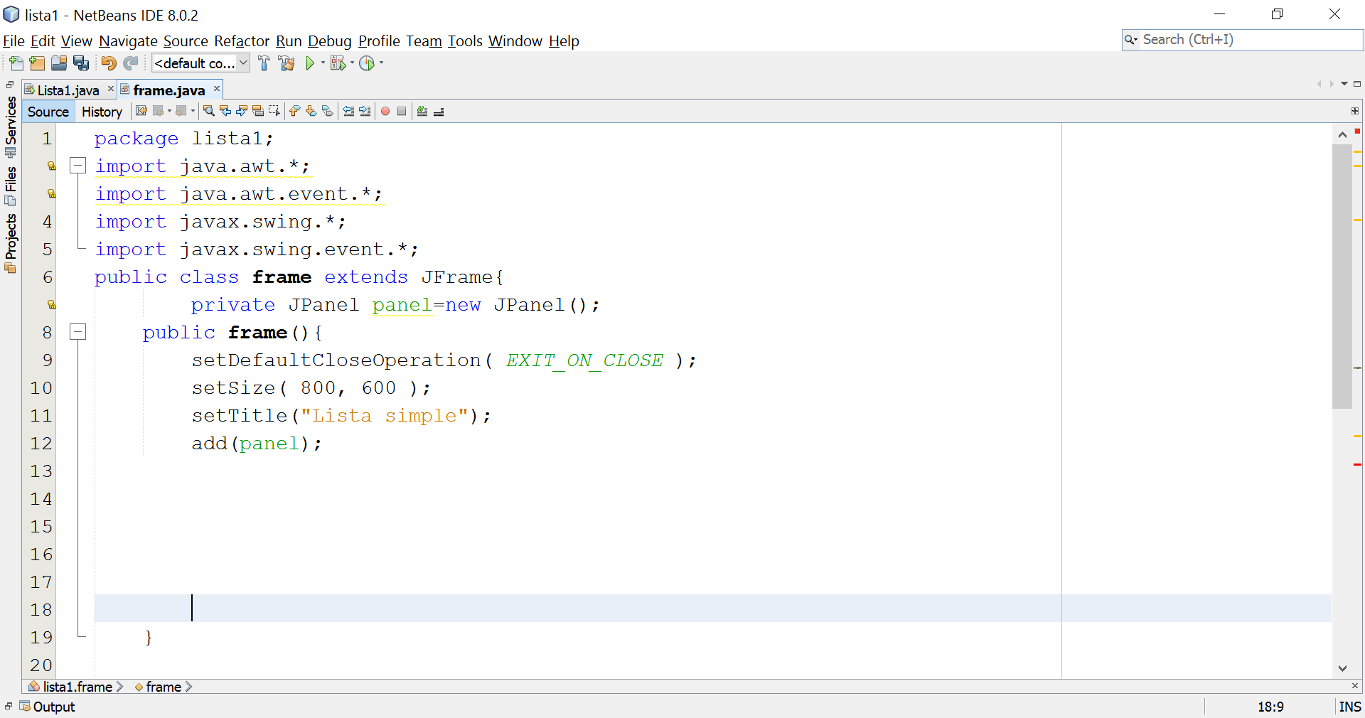

I add necessary variables to instantiate a Jlist:
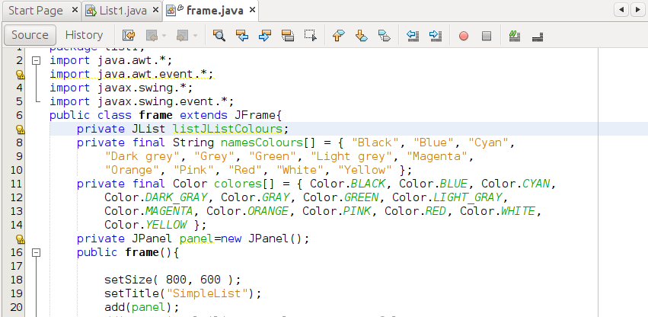

The vector namesColors will serve to create the JList and the vector colors to change the color of the panel according to the user choose one from the list:

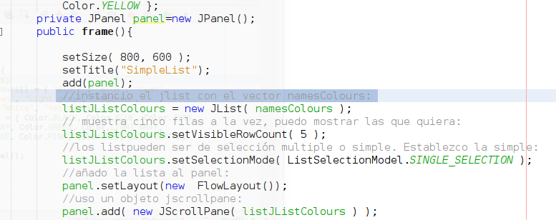

To test what we have done we instantiate a frame in lista1.java:
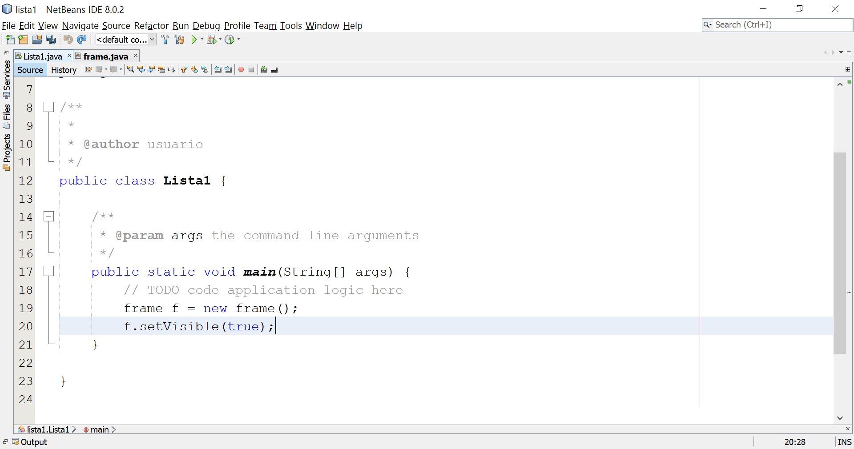

If we execute:
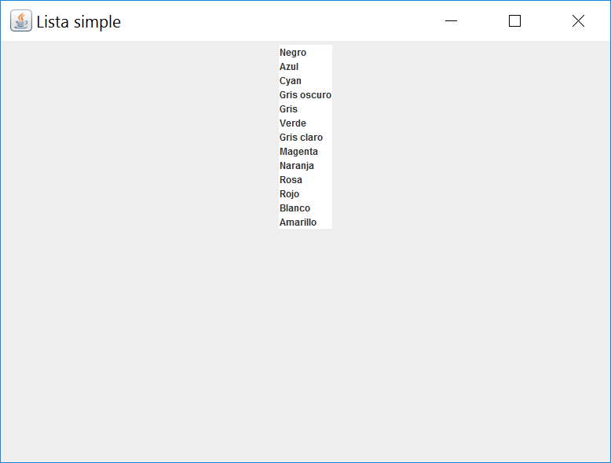

We see that the list does not have the desired appearance. That's because lists don't automatically include a scroll bar like combos do. Add the list to a JScrollPane object:

If we run now:
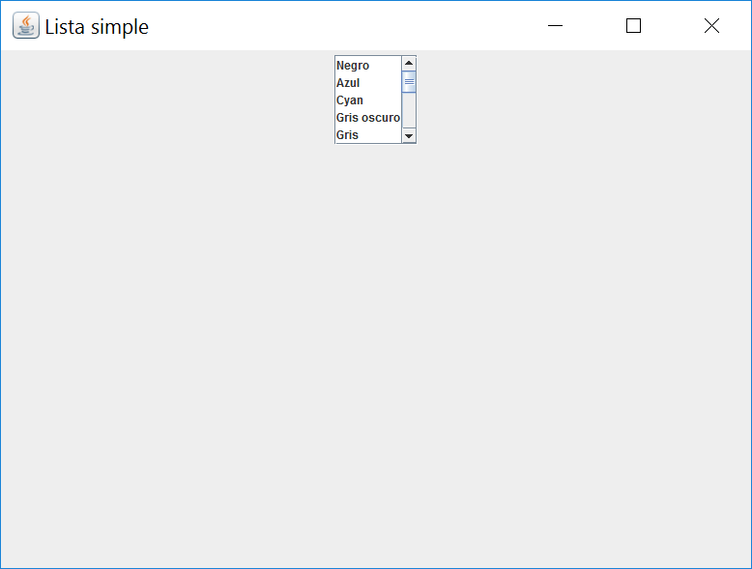
Now if it has the look we want.
It remains to create an event handler for the list and add this event handler to the list:

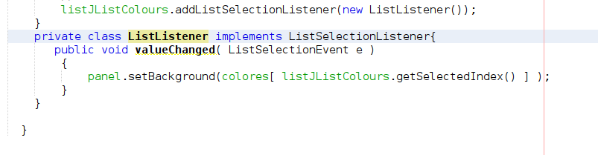

We obtain the color for the panel background by indexing the colors in the vector by means of the integer that the jlist returns to us using the getSelectedItem property in a similar way as we did with combos.
If we execute we will observe that the panel will change the color according to the user you select an element from the jlist.

